Helm with statement

* With in Helm in used to change the current scope.
* Now let’s look at created helm chart by using helm create command

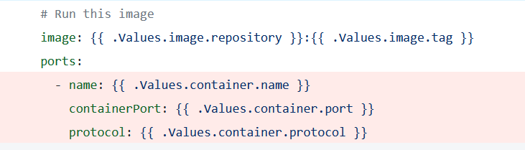

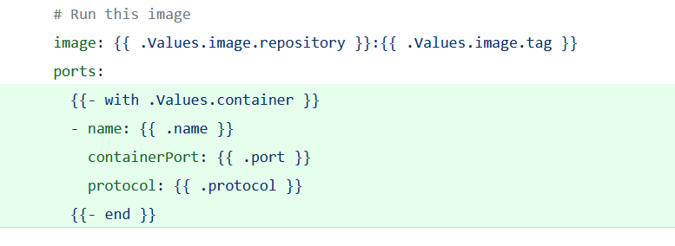

Named Templates

* Ref: <https://helm.sh/docs/chart_template_guide/named_templates/> for the official docs

